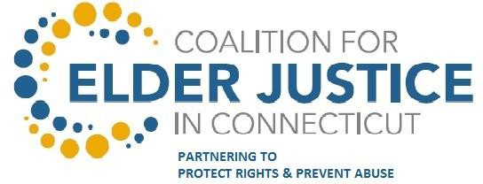

COALITION MEMBERSHIP FORM
Purpose: By completing and returning this form, you indicate an interest in becoming or staying involved in the Coalition for Elder Justice in Connecticut. As a Coalition member, you become part of a system of public and private stakeholders working together to achieve the vision and goals of the Coalition to prevent elder abuse and protect the rights, independence, security, and well-being of vulnerable elders through communication and collaboration.. You and/or your organization may be identified on the website as a member of the Coalition for Elder Justice in Connecticut, receive information and updates, and have opportunities to participate in Action Teams / Workgroups, Seminars, Conferences or other implementation activities of the Coalition.
Instructions: Please complete both sides this form and return to Lara.Stauning@ct.gov The Organization Description will be included on the Coalition website.

Contact Name
Credentials
Position:Title:
Name of Agency or Organization
Name of Program or Service
Street Address
City/town
State
Zip | 00000
Telephone Number
Fax Number
Email
Website

- I will be Participating as the designated representative for my agency/organization.
☐Yes ☐No
- My agency/organization will provide a link on our webpage to the Coalition for Elder Justice Connecticut webpage (https://elderjusticect.org)
☐Yes ☐No
- The Scope of my agency’s/organization’s work is (Check One):
☐Statewide ☐ Regional ☐ Local ☐ Tribal

Please indicate which sector best describes your agency/organization (select one)

 | ☐Elected Official (state or local) | ☐Justice/Law Enforcement
☐American Indian Tribe | ☐ Faith Community | ☐ Legislative Committee
☐ Business and Industry (health insurer, other business, professional assoc. | ☐ Health Care Provider (medical, dental, behavioral) | ☐ Philanthropy
☐ State agency or office | ☐ Local Health Department | ☐ Health Professional Associations
☐ Community Service Providers (Elder, Family/Youth, special populations) | ☐ Housing/Building Safety | ☐ Transportation
☐ Education (Higher Ed/Technical College | ☐ Non-profit Organization and Coalitions (E.G. AAA, LGBT, etc.) | ☐ Other (please specify):

ORGANIZATION DESCRIPTION FOR WEBSITE
SAMPLE:
(Organization Name and subdivision if required)

Center for Elder Abuse Prevention at Jewish Senior Services

(Description – Please limit to 100 words or less)
The Center for Elder Abuse Prevention serves frail elderly in Fairfield County. Its mission is to empower victims of elder abuse and champion safe communities for older adults. Primary services include: Crisis Shelter and Geriatric Services for victims facing immediate threats; Telephone Helpline with trained victims’ advocates to offer assistance and referrals; Collaboration with allied professionals and coordination of the community-based Coalition for Abuse Prevention of the Elderly (CAPE); and Public Education and Outreach to bring awareness to the growing problem of elder abuse.

Contact
Helpline 203-396-1097
Email: elderabuseprevention@jseniors.org Primary Contact: Laura Snow Robinson
Website: http://jhe.org/services/advocacy-education/elder-abuse-prevention/

SUBMISSION:
Organization Name and subdivision as required:

Description – Please limit to 100 words or less:

Contact:
Business or Helpline Telephone Number: Email:
Primary / Secondary Points of Contact:
Website:

